1.

Debugged snippet

<html lang="en">

    <head>

        <title>Document

                guvi

        </title>

    </head>

    <body>

     <div>

        Lorem ipsum dolor sit amet consectetur adipisicing elit.

     </div>

            <div>

                Guvi Geek Network

            </div>

    </body>

    </html>

2. Debugged snippet

<html lang="en">

    <head>

        <title>Document</title>

    </head>

    <body>

        guvi

       <div>

           Lorem ipsum dolor sit amet consectetur adipisicing elit.

       </div>

            <div>

                Guvi Geek Network

            </div>

        </body>

    </html>

1. In your, HTML page add the below line and Highlight it without using any CSS.

* "HTML & CSS is awesome"

<!DOCTYPE html>

<html lang="en">

<head>

    <meta charset="UTF-8">

    <meta http-equiv="X-UA-Compatible" content="IE=edge">

    <meta name="viewport" content="width=device-width, initial-scale=1.0">

    <title>Document</title>

</head>

<body>

    <div style="background-color: bisque;">

    <p>"HTML & CSS is awesome"</p>

</div>

</body>

</html>

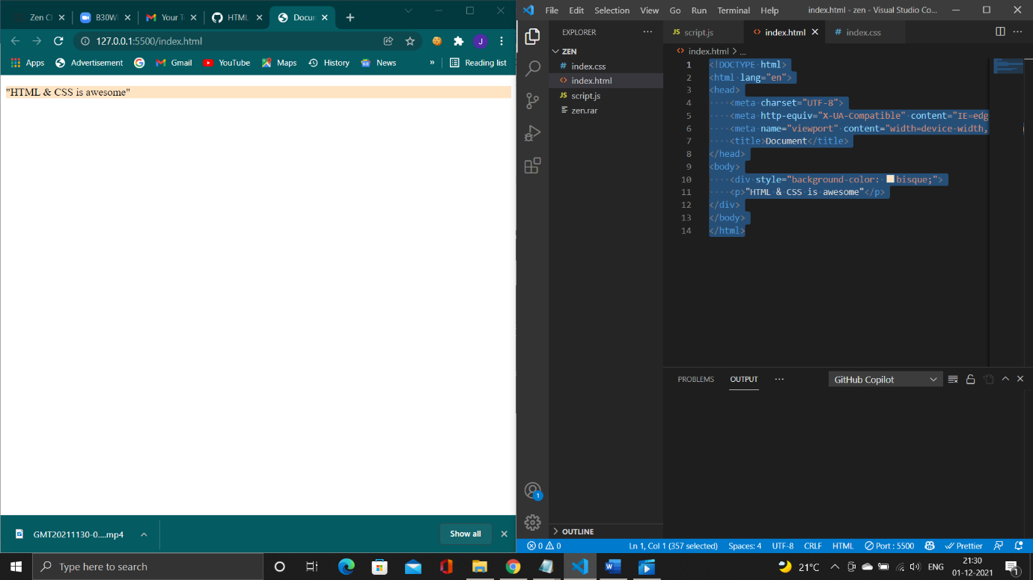

1. Use certain HTML elements to display the following in a HTML page.

<!DOCTYPE html>

<html lang="en">

<head>

    <meta charset="UTF-8">

    <meta http-equiv="X-UA-Compatible" content="IE=edge">

    <meta name="viewport" content="width=device-width, initial-scale=1.0">

    <title>Document</title>

</head>

<body><ul>

    <li>Programing language</li>

<ul>

    <li>Javacript</li>

        <ol type="a">

            <li>Angular</li>

            <li>React</li>

            <li>Vue.js</li>

        </ol>

    <li>Python</li>

    <ol type="a">

        <li>Django Framework</li>

        <li>Flask Framework</li>

    </ol>

    <li>Java</li>

    <ol type="a">

        <li>Spring </li>

        <li>Maven</li>

        <li>Hibernate</li>

    </ol>

</ul>

    <li>Database</li>

    <ul>

    <li>MySQL</li>

    <li>MongoDB</li>

    <li>Cansandra</li>

    </ul>

</ul>

</body>

</html>

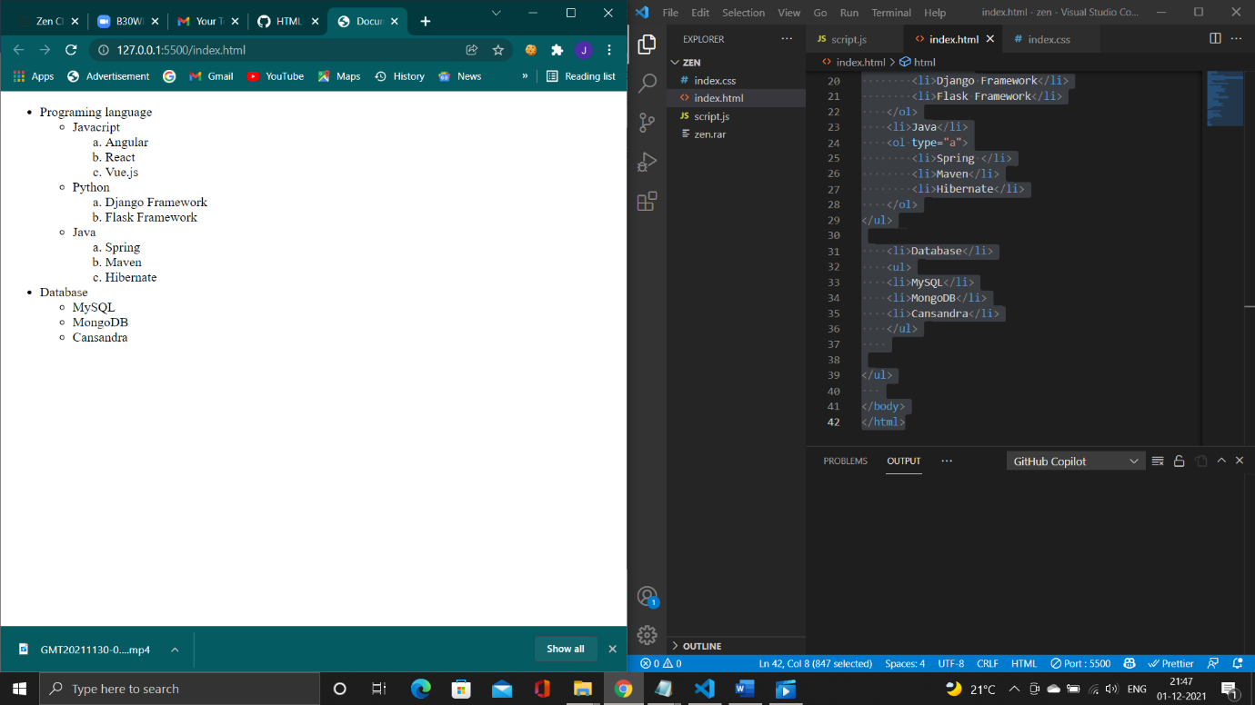

1. Write HTML input tags snippet to show default values for all Form elements.

<!DOCTYPE html>

<html lang="en">

<head>

    <meta charset="UTF-8">

    <meta http-equiv="X-UA-Compatible" content="IE=edge">

    <meta name="viewport" content="width=device-width, initial-scale=1.0">

    <title>Document</title>

</head>

<body>

    <form action = "https://www.linkedin.com/" method = "post">

        <label for="firstname"> First name:</label>

        <input type= "text" value= "JAy" name= "firstname" placeholder=""><br/>

        <input type = "submit" value =" submit">

</body>

</html>

By adding value keyword for input type snippet produces default value in screen

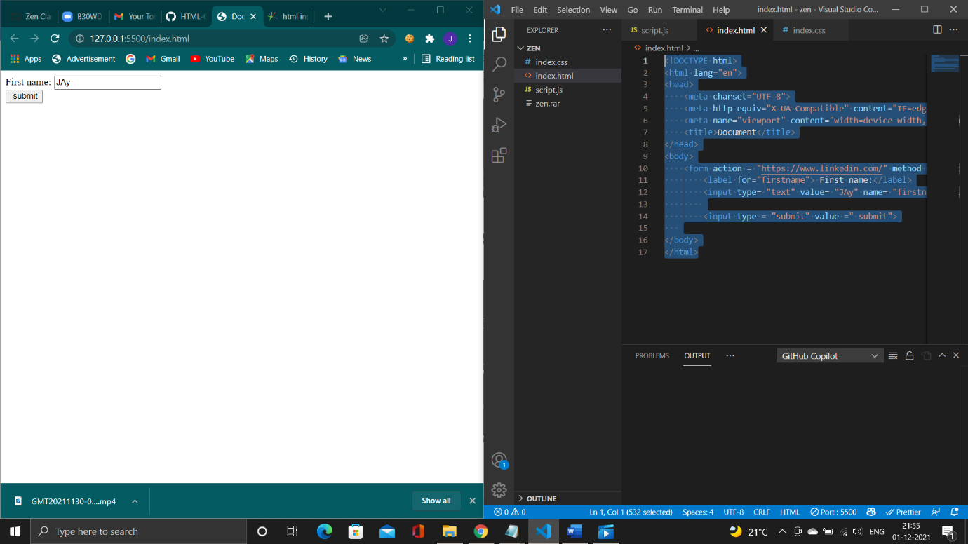

1. Create an HTML page, which should contain all types of input elements.

<!DOCTYPE html>

<html lang="en">

<head>

    <meta charset="UTF-8">

    <meta http-equiv="X-UA-Compatible" content="IE=edge">

    <meta name="viewport" content="width=device-width, initial-scale=1.0">

    <title>Document</title>

</head>

<body>

    <label for="Button"> Button:</label></br>

    <input type="button"></br>

    <label for="chekbox"> checkbox:</label></br>

<input type="checkbox"></br>

<label for="color"> color:</label></br>

<input type="color"></br>

<label for="date"> date:</label></br>

<input type="date"></br>

<label for="date time"> date time:</label></br>

<input type="datetime-local"></br>

<label for="email"> email:</label></br>

<input type="email"></br>

<label for="file"> file:</label></br>

<input type="file"></br>

<label for="hidden"> hidden:</label></br>

<input type="hidden"></br>

<label for="image"> image:</label></br>

<input type="image"></br>

<label for="month"> month:</label></br>

<input type="month"></br>

<label for="number"> number:</label></br>

<input type="number"></br>

<label for="password"> password:</label></br>

<input type="password"></br>

<label for="radio"> radio:</label></br>

<input type="radio"></br>

<label for="range"> range:</label></br>

<input type="range"></br>

<label for="reset"> reset:</label></br>

<input type="reset"></br>

<label for="search"> search:</label></br>

<input type="search"></br>

<label for="submit"> submit:</label></br>

<input type="submit"></br>

<label for="tel"> tel:</label></br>

<input type="tel"></br>

<label for="text"> text:</label></br>

<input type="text"></br>

<label for="time"> time:</label></br>

<input type="time"></br>

<label for="url"> url:</label></br>

<input type="url"></br>

<label for="week"> week:</label></br>

<input type="week"></br>

</body>

</html>

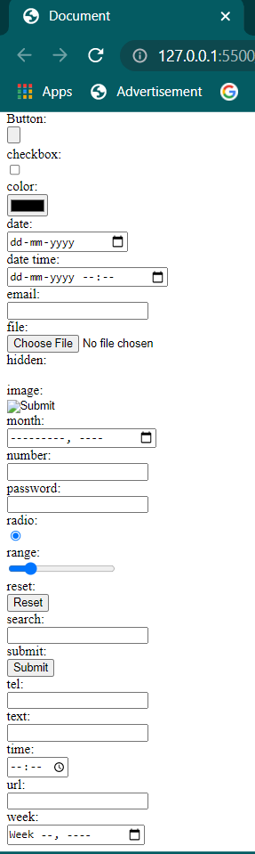

1. In the form, add two radio buttons with grouping them for employee type(Salaried and own business)

<!DOCTYPE html>

<html lang="en">

<head>

    <meta charset="UTF-8">

    <meta http-equiv="X-UA-Compatible" content="IE=edge">

    <meta name="viewport" content="width=device-width, initial-scale=1.0">

    <title>Document</title>

</head>

<body>

    <form action = "https://www.google.com" method = "post">

        <label for="Employeegrouping"> Employee Grouping:</label></br>

        <label for="Salaried">  Salaried:</label></br>

        <input type= "checkbox"> </br>

        <lable for = "own business"> Own Business:</lable></br>

        <input type = "checkbox"><br/>

        <input type = "submit" value =" submit">

</body>

</html>

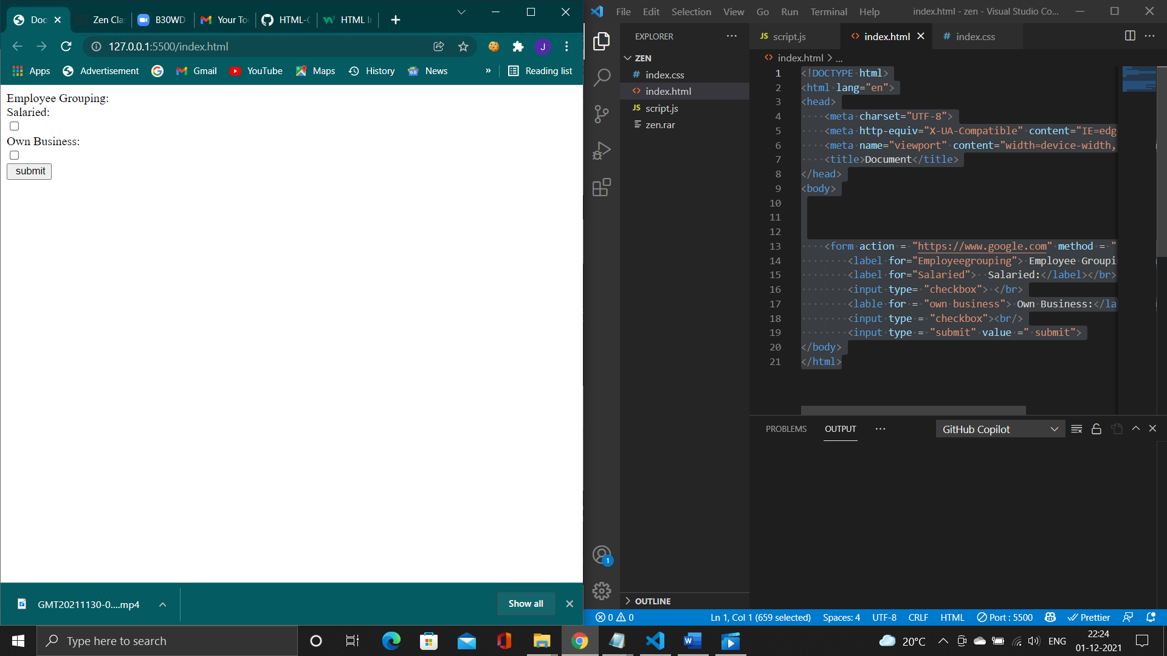

1. Design a contact us form with all fields as required.

<!DOCTYPE html>

<html lang="en">

<head>

    <meta charset="UTF-8">

    <meta http-equiv="X-UA-Compatible" content="IE=edge">

    <meta name="viewport" content="width=device-width, initial-scale=1.0">

    <title>Document</title>

</head>

<body>

    <form action = "https://www.google.com" method = "post">

        <div style ="background-color: cadetblue;"><label for="ContactUS"> ContactUS:</label></br></div>

        <div style ="background-color: cadetblue;"><label for="Name">  Name:</label></br>

        <input type= "text" value="" placeholder="Your name!"> </br></div>

        <div style ="background-color: cadetblue;"><lable for = "Email"> Email:</lable></br>

        <input type = "email" value="" placeholder="your Email!"><br/></div>

        <div style ="background-color: cadetblue;"><label for="Phone Number">Phone Number:</label></br>

        <input type= "Number" value="" placeholder="Your Number!"></div>

        <div style ="background-color: cadetblue;"><label for="Text Area">Text Area:</label></br>

        <textarea></textarea></div>

        <input type = "submit" value ="Send">

</body>

</html>

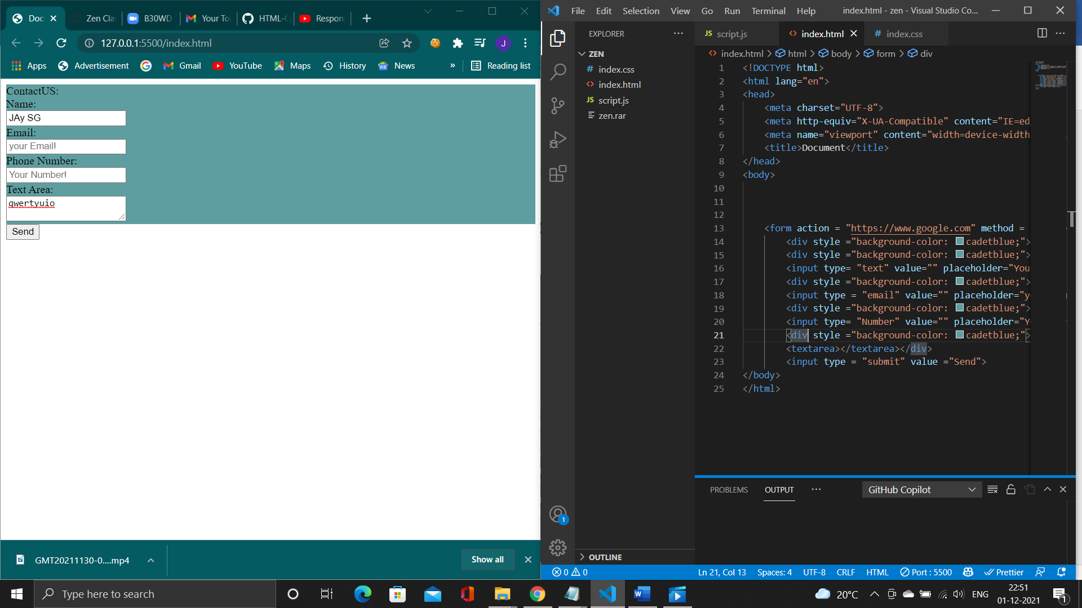

1. Create an element that helps you to open the [https://google.com](https://google.com/) in separate new tab.
2. <!DOCTYPE html>
3. <html lang="en">
4. <head>
5. <meta charset="UTF-8">
6. <meta http-equiv="X-UA-Compatible" content="IE=edge">
7. <meta name="viewport" content="width=device-width, initial-scale=1.0">
8. <title>Document</title>
9. </head>
10. <body>
11. <h1>Google</h1>
12. <a href="https://www.google.co.in/" target="_blank">clickhere</a>
13. </body>
14. </html>

Using target=”_”blank tag opening [https://google.com](https://google.com/) in separate new tab is achived.

8

<!DOCTYPE html>

<html lang="en">

<head>

    <meta charset="UTF-8">

    <meta http-equiv="X-UA-Compatible" content="IE=edge">

    <meta name="viewport" content="width=device-width, initial-scale=1.0">

    <link rel = "stylesheet" href="index.css">

    <title>Document</title>

</head>

<body>

  <table border="1"  cellpadding="5">

      <tr>

              <th>State of Health </th>

              <th>Fasting Value</th>

                 <th>      </th>

              <th>    After Eating</th>

      </tr>

      <tr>

          <td>      </td>

          <th>minimum</th>

          <th>maximum</th>

          <th> 2hours after EAting</th>

      </tr>

      <tr>

          <td>Healthy</td>

          <td>70</td>

          <td>100</td>

          <td>Less than 140</td>

      </tr>

      <tr>

          <td>Pre-Diabetes</td>

          <td>101</td>

          <td>126</td>

          <td>140 to 200</td>

      </tr>

      <tr>

          <td>Diabetes</td>

          <td>More than 126</td>

          <td>NA</td>

          <td>more than 200</td>

      </tr>

  </table>

</body>

</html>

